## World Bank Data Based Analysis on Climate Change for 10 Countries

## By: Pavanteja Turaka------Student id: 21080899

**Abstract:** The term "Climate Change (CC)" is used to describe a long-term shift in the average values of climatic indicators including temperature, precipitation, snowfall, and wind speeds. The Earth's climate has fluctuated countless times over the planet's history. It is a genuine and urgent concern that is already hurting individuals and the environment globally. In this overview, we'll look at the various factors that have contributed to global warming. Raising attention, theoretical research, feedback systems, and model simulations all benefit from a deeper knowledge of the underlying causes of CC. Biggest environmental problems in the world is climate change. We use data from the World Bank[1] to analyze how the climate is changing, and we base our study on graphical techniques including line graphs (Line charts are used to show the relationship between two sets of data (X and Y) on a separate axis), bar graphs (a type of bar chart in which the height and width of the bars are directly related to the data they display), and heatmaps (coefficients to show the degree of correlation between variables). The libraries pandas (it is used to analyze data), NumPy (a Python module for handling arrays), and matplotlib (By using Python scripts, the Matplotlib library allows users to construct 2D graphs and plots) are used in all of these methods. Utilizing Jupyter notebook and Python for all work. Graphs are an effective way to display climate change.

**Introduction:**  CC affects the quantity and quality of available food (Djoundourian, 2021). Increasing temperatures, shifting patterns of precipitation, shifting frequencies and intensities of severe weather events, and diminished water availability are a few potential causes of decreased agricultural productivity. We compiled this dataset from the World Bank. The dataset name is World Development Indicator. The dataset includes information on the agricultural land area per square metres for many countries between 1990 and 2020. A World Bank assessment on India's water economy asserts that the country is rapidly running out of water, would be severely stressed by 2020, and anticipates that by 2050, demand will outpace supply. The demand for water will inevitably increase in an environment with rapid economic growth While some areas of India are experiencing a flood, some are suffering from the intense sun. Climate changes brought on by humans are another cause of these discrepancies. The vast majority of scholars examining the issue and potential solutions come from developed nations, despite the fact that the issue has global consequences, and the involvement of less industrialised nations has been very restricted.

The following elements have been chosen to be examined through (Alex and Kumar, 2019) analyses of data relevant to many nations on their respective continents:

Urban population, yearly population growth, net inflows (as a percentage of GDP), agricultural land (sq. km.), "CO2 emissions from liquid fuel use (% of total)," foreign direct investment, net inflows (as a percentage of GDP), and indicators are also given.

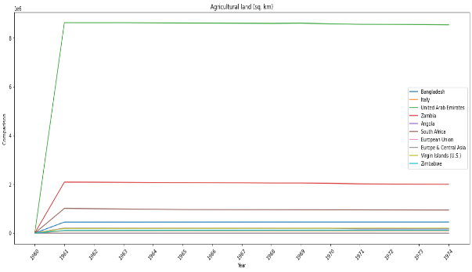

Figure 1: Line Graph (Agriculture Land)

The 'Agriculture land (sq. km)' in the country of the United Arab Emirates has been increasing from one year to the next, while it has been decreasing in South Africa, according to the data presented, since plotting a line graph, when selecting data for use in creating the graph based on the name of the indicator.

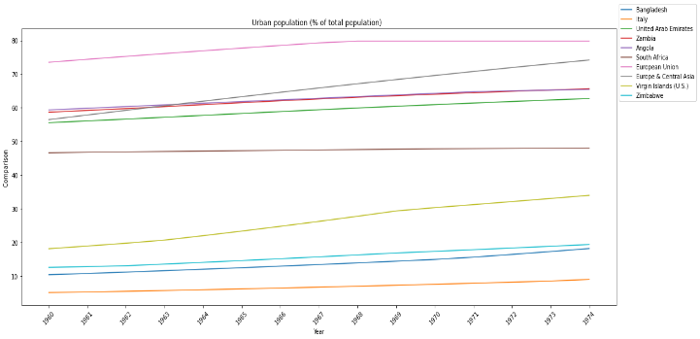

Figure 2: Pie Graph (Urban Population)

To create a pie graph, choose information based on "Urban population (% of total population)," such as the nation and the year. Based on the information provided, it can be concluded that Italy has the lowest percentage of its people living in urban areas, whereas the European Union has the largest percentage.

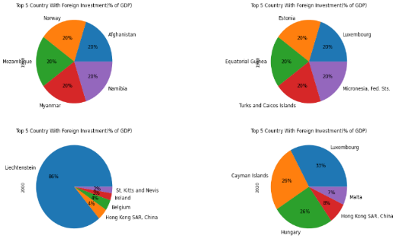

Figure 3: Bar Graph (Urban Population)

Select data based on "Urban population (% of total population)," such as the country and the year, to build a bar graph.

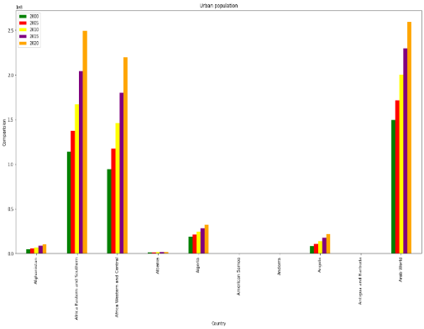

Figure 4: Bar Graph (Arab World)

Choose data for the next bar graph based on urban population, using information from the top 10 nations between 2000 and 2020. It can be seen from the graph that the percentage of people who live in urban areas is largest in the "Arab World" and that this percentage is increasing with time.

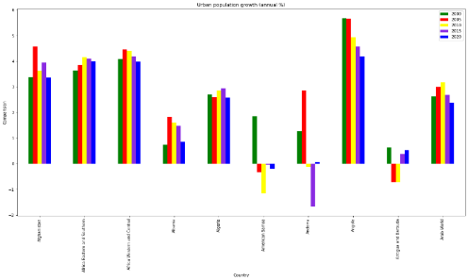

Figure 5: Bar Graph (Top 10 Nation)

Depending on the yearly percentage increase of their urban populations, the top 10 nations' statistics from 2000 to 2020 were chosen for the aim of creating a bar graph. According to the figure, even if this increase is slowing down year by year, "Angola" has the greatest ratio of population growth in urban areas.

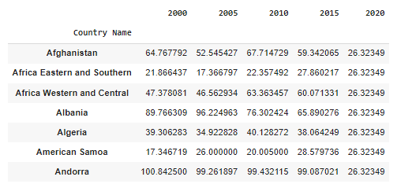

Figure 6: Bar Graph (Top 10 Countries Data)

The top 10 countries' data from 2000 to 2020 were picked with the intention of constructing a bar graph based on the yearly percentage rise of their urban populations.

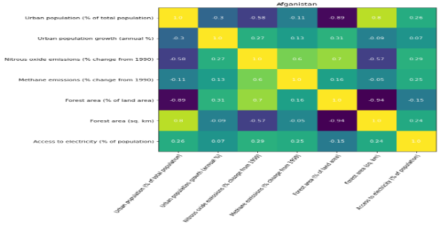

Figure 7: Heatmap Graph for Afghanistan

In the heatmap graph for Afghanistan, the presence of a positive connection between "Forest area (sq. km)" and "Nitrous oxide (% change from 1990)".

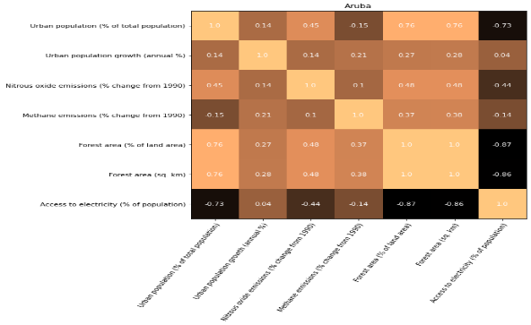

Figure 8: Heatmap Chart (Aruba)

When constructing the heatmap chart for the nation of "Aruba," it was discovered that the Forest area (sq. km) had a negative association with the other elements in the picture but a little positive correlation with "Urban population rise (annual%)".

**References**

Alex, P. and Kumar, S. K. (2019) ‘Climate Change Research literature in India: A Scientometric Analysis during 1991 – 2018’, *Library Philosophy and Practice*.

Djoundourian, S. S. (2021) ‘Response of the Arab world to climate change challenges and the Paris agreement’, *International Environmental Agreements: Politics, Law and Economics*. doi: 10.1007/s10784-021-09524-9.

1. *https://data.worldbank.org/topic/19*